Project Design Phase-II
Technology Stack (Architecture & Stack)

Date | 3 October 2026
Team ID | SWTID-2026-3878
Project Name | Implementing Client Scripts and UI Policies on the ServiceNow Incident Form
Maximum Marks | 4 Marks

Technical Architecture:
The Deliverable shall include the architectural diagram as below and the information as per the table1 & table 2
Architecture of our project: ServiceNow Incident form
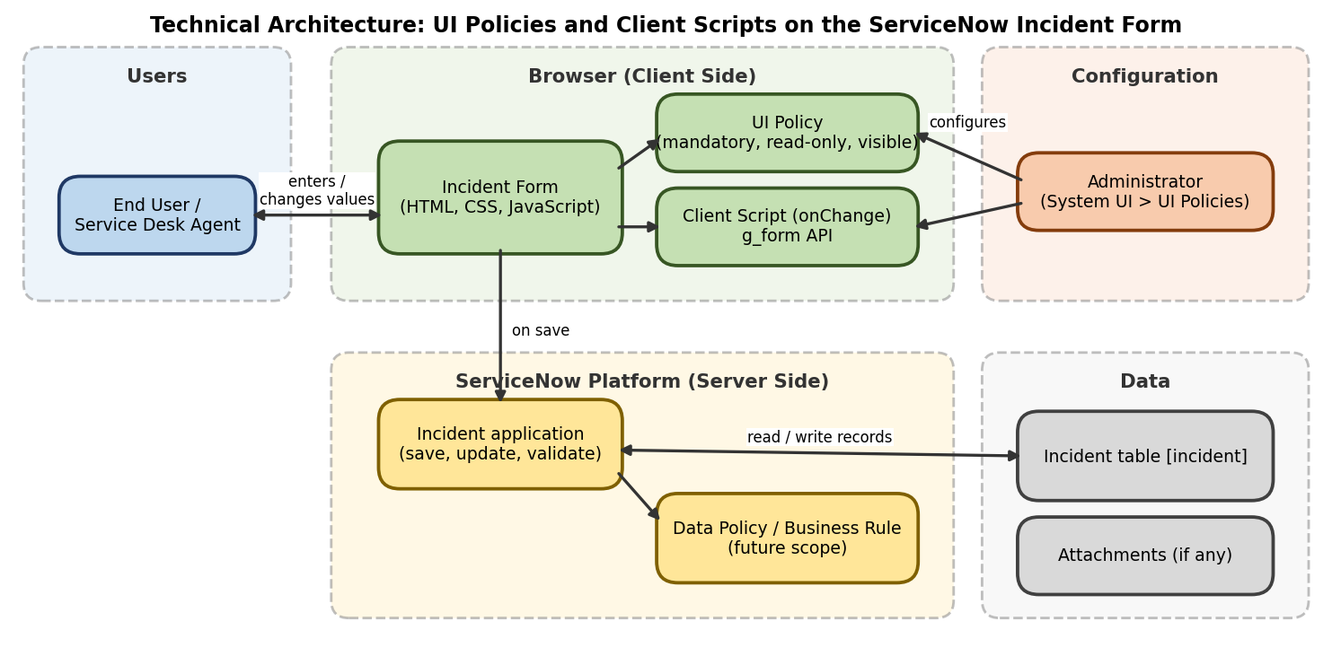
Table-1 : Components & Technologies:
S.No | Component | Description | Technology
 | User Interface | The Incident form where users enter data and see fields react as they work | ServiceNow Incident form (HTML, CSS, JavaScript)
 | Application Logic-1 | UI Policy on the Incident table makes fields mandatory, read-only or visible when a condition is met | ServiceNow UI Policy and UI Policy Actions
 | Application Logic-2 | Client Script runs when the State field changes and shows or clears field messages | Client Script (onChange), JavaScript, g_form API
 | Application Logic-3 | Server-side rules so the same checks apply to imports and API updates (future scope) | Data Policy / Business Rule
 | Database | Stores Incident records, including fields such as State, Caller and Hold reason | ServiceNow Incident [incident] table
 | Cloud Database | ServiceNow instance in the cloud holds and serves the data | ServiceNow cloud instance (Personal Developer Instance)
 | File Storage | Attachments added to incidents, if any | ServiceNow attachment storage
 | External API-1 | Not used in this project | Not applicable
 | External API-2 | Not used in this project | Not applicable
 | Machine Learning Model | Not used in this project | Not applicable
 | Infrastructure (Server / Cloud) | Application deployment on the ServiceNow cloud platform  Local Server Configuration: not required, as the logic runs in the browser  Cloud Server Configuration: ServiceNow Personal Developer Instance, hosted by ServiceNow | ServiceNow cloud platform

Table-2: Application Characteristics:
S.No | Characteristics | Description | Technology
 | Open-Source Frameworks | ServiceNow is a proprietary platform; the client-side logic uses standard JavaScript | JavaScript (client side)
 | Security Implementations | Access to create or change UI Policies and Client Scripts is limited to administrators; ServiceNow roles and access controls still apply | ServiceNow roles and ACLs, authenticated login
 | Scalable Architecture | Multi-tier platform; the same UI Policy approach can be extended to other tables such as Change and Problem | ServiceNow multi-tier cloud platform
 | Availability | Available whenever the ServiceNow instance is available, as no separate service is needed | ServiceNow cloud-hosted instance
 | Performance | UI Policies and Client Scripts run in the browser, so fields respond without a server call or noticeable delay | Client-side execution in the browser

